Investigation: The Cell Cycle and Cancer Name: ________________________________ per._____

Purpose: In this investigation you will explore the similarities and differences between the cell cycles of normal cells and cancer cells.
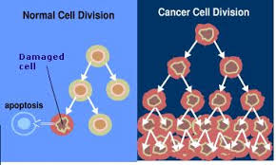
PART I. Read textbook page 509 and answer these explain questions below:
- What is cancer?
is a disorder in which body cells lose the ability to control growth.

- Finish this statement: Cancer cells do NOT respond to ……….
to the signals that regulate the growth of most cells. As a result, the cell
cycle is disrupted and the cells grow and divide uncontrollably.

- What is a tumor?
A mass of cells that have grown out of control

What is the difference between a benign tumor and a malignant tumor? Which is more dangerous?
→ Difference: A benign tumor does NOT spread to surrounding healthy tissue or other parts of the body
WHEREAS a malignant tumor invades and destroys healthy tissue and does spread throughout the body.

→ Danger: Malignant tumors are DANGEROUS.
- What causes cancer?
Cancers are caused by defects (mutations) in the genes that regulate cell growth and division.

- An astonishing number of cancer cells have a defect in a specific gene (specific DNA information).
What gene is this AND what is this gene responsible for?
The defect happens in the p53 gene, which produces a checkpoint protein which would normally halt the cell
cycle until chromosomes have been properly replicated. So a damaged p53 gene causes cells to lose the ability
to respond to signals to control cell growth.

PART 2:
- Watch this short video to introduce yourself to how the cell cycle differs between normal and cancerous cells:
  - Unregulated Cell Division

Observations: List some differences between the normal cells and cancerous cells dividing. List ALL Types of observations.

- Using the data gathered for you from normal and cancerous stomach tissue samples, calculate the mitotic index.
- To calculate the mitotic index: Number of cells in the process of dividing ÷ Total number of cells.

Data Table: Number of Cells In Division for Healthy and Cancerous Tissue Samples
Tissue Type | # of Cell in Interphase | # of Cell in Prophase | # of Cell in Metaphase | # of Cell in Anaphase | # of Cell in Telophase | Total # of Cells | Mitotic Index
Normal Stomach Tissue Sample | 18 | 0 | 1 | 0 | 1 | 20 | 0.10
Cancerous Stomach Tissue Sample | 14 | 2 | 1 | 1 | 2 | 20 | 0.30

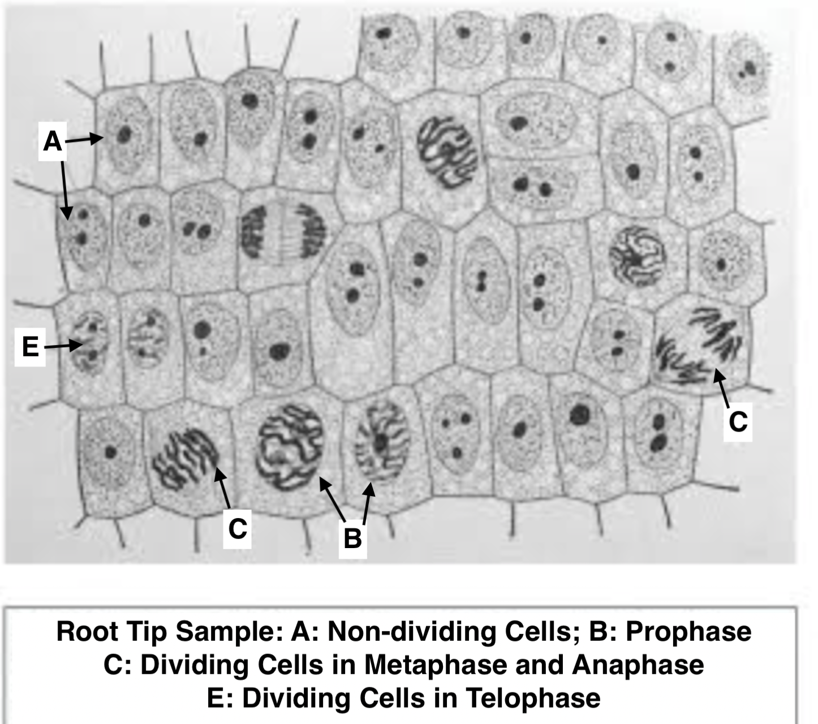
- Using the picture to the LEFT, fill in the headers below and calculate
the mitoticiIndex

- # of Non-dividing Cells: ___31__
- # of Cells in Prophase:__4____
- # of Cells in Metaphase/Anapahse: __3___
- # of Cells in Telophase: ___2___
- Total # of Cells: __40____
- Mitotic Index: __0.225___

- If the picture to the LEFT was a tissue sample of a stomach cells,
would this be considered NORMAL or Cancerous?
Explain your answer using DATA
Cancerous. The Mitotic Index (0.225) is closer to the cancerous
mitotic index for cancerous cells stomach cells (0.30)

PART 3: What causes melanoma (A type of cancer)?
To begin, watch the video, “Teen Survives Deadly Melanoma” (https://www.youtube.com/watch?v=Zj4Bbu0xwRY).
1. What questions do you have about melanoma and the events described in the video?

You will learn the answers to many of your questions as you complete this activity.

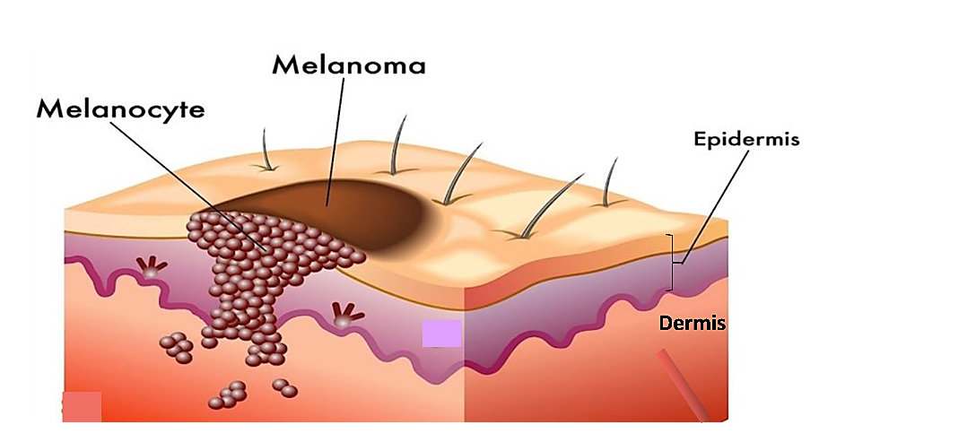
What is a Melanoma?

Melanoma is a type of skin cancer. A melanoma begins when a type of skin cell called a melanocyte divides excessively and the cells spread beyond their normal location. (See the first figure.)

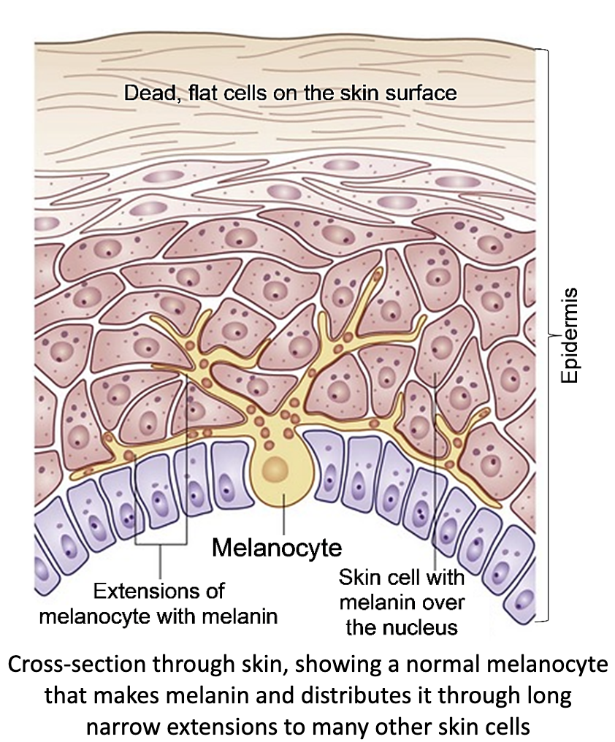
A melanocyte is a type of skin cell that makes melanin and distributes it to other skin cells. (The second figure shows the normal shape and location of a melanocyte.)

Melanin is a molecule that absorbs UV rays,
which prevents UV rays from damaging DNA.

2. Inside most skin cells, most of the melanin is located between the cell’s
nucleus and the surface of the skin. How does that location allow melanin to
protect the cell’s DNA?
It is a barrier that protects the melanocyte’s DNA by absorbing the UV
rays

How does a melanoma develop?
UV light can damage the DNA of skin cells. If the damage is not repaired correctly, this results in a mutation. A mutation is a permanent change in the DNA. This figure on the NEXT PAGE shows how multiple mutations in the DNA of melanocytes can result in a melanoma.

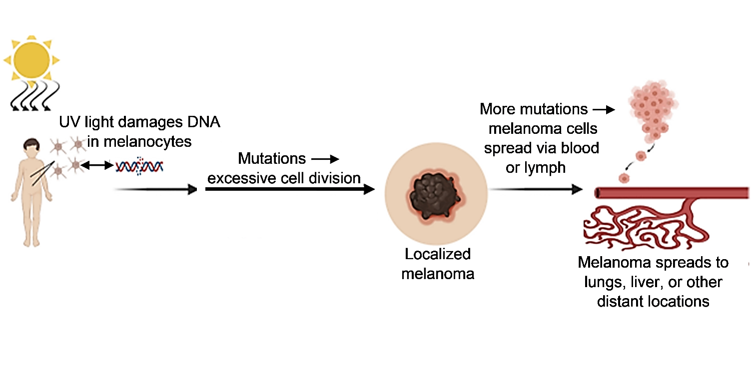
A
B
C
3. The next three paragraphs describe how a melanoma can develop. Put the letter for each paragraph next to the
corresponding part of the figure above.

A. Mutations in the DNA of melanocytes can disrupt the normal regulation of cell division, which can result in excessive, out-of-control cell division. This produces a localized melanoma. Surgical removal of a localized melanoma can cure the cancer.

B. If a localized melanoma is not surgically removed, then the DNA of the melanoma cells may accumulate more mutations that allow these cells to spread via the circulatory and lymph systems. In the lymph nodes, immune cells can attack and kill the melanoma cells.

C. If the immune cells and surgery do not eliminate all of the melanoma cells, the surviving melanoma cells can establish metastatic melanoma in the lungs, liver or other organs. Metastatic melanoma can kill a person by interfering with the function of the organ where it is located and by using so much nutrition that healthy cells in the rest of the body do not get adequate nutrition. (metastasis means a cancerous cell has broken away from the tumor and enters the blood vessels)

4a. The first doctor of the teen in the video removed the melanoma on her face. However, he warned her that the
melanoma could kill her in five years. After the melanoma on her face was removed, where could melanoma cells be
in her body?
The melanoma could have traveled into her lymph nodes (and circulatory system)

4b. How could the melanoma eventually result in her death?
One of the cancerous melanoma cells could break off and travel to another part of the body and cause cancerous
(tumor) growth there. Depending on where it landed, it could result in her death.

To prevent the melanoma from possibly killing the teen, her second doctor removed lymph nodes (in case they contained melanoma cells). He also prescribed medicines to help her immune cells recognize and destroy melanoma cells more effectively.

Why do melanoma cells divide too much?

To understand why melanoma cells divide too much, you first need to understand that normal cell division is regulated by checkpoints. At the first checkpoint, a normal cell begins cell division only if growth factor is bound to a receptor on the cell membrane and the cell’s DNA is not damaged.

Growth factor (an external stimulus) is a signal that more melanocytes are needed, so cell division should proceed. If there is no growth factor, then a normal melanocyte will not divide and instead will differentiate to begin producing melanin and distributing melanin to other skin cells.

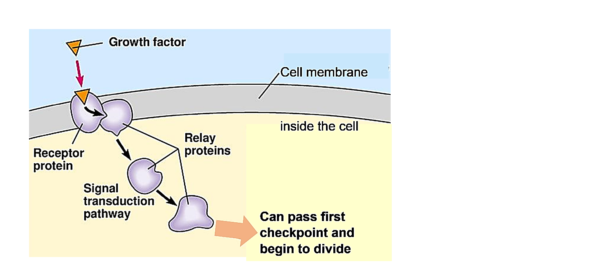
This figure shows a few of the molecules that contribute to the function of this first checkpoint.
When growth factor binds to a receptor protein in the cell membrane, this activates a series of relay proteins.
The activation of the final relay protein allows cell division to begin.
*YOU DO NOT NEED TO MEMORIZE THIS DIAGRAM/ PROCESS

5. Suppose that UV rays have damaged the DNA in a melanocyte and caused a mutation in the DNA for the final relay
protein. Suppose that this mutated information gives the instructions for making an abnormal/ defective relay protein
which is permanently active, even when no growth factor is bound to the receptor protein.
How would this mutation contribute to the development of a melanoma?
It would cause the cell to pass the checkpoint and divide causing uncontrolled cell growth

In addition to checkpoint proteins (Cyclins) that can move the cell cycle forward, there are checkpoint proteins that can pause the cell cycle when needed. For example, if a cell’s DNA is damaged, the p53 checkpoint protein pauses the cell cycle and stimulates the production of DNA repair enzymes. If the cell cannot repair the DNA damage, the p53 checkpoint protein stimulates the cell to kill itself (sometimes called “cell suicide” or Apoptosis).

6a. How does this apoptosis response help to preserve your health?
Apoptosis helps by getting rid of mutated cells before they divide and cause more mutated cells
(tumors)

6b. Suppose that DNA information for the p53 protein is mutated, so a cell has no functional p53 protein. Explain how
this would contribute to the development of a melanoma.
If cells were mutated there would not be proteins to pause the cell’s cycle and DNA enzymes would
not be called to fix the cell before it moved along in the cell cycle. Thereby allowing mutated cells to
grow constantly.

In summary, mutated DNA information for defective checkpoint proteins results in major contributions to the development of a melanoma.

Environment and inherited genes influence your risk of melanoma.

7. A person who has had sunburns as a child or teen is more likely than a person who has never had a sunburn
to develop melanoma. Explain why. (Hint: Look back at the bottom of page 2,”How does a melanoma develop?” .)
Children who have had sunburns have been exposed to harmful UV radiation, which could cause
mutations that are permanent. These mutations can accumulate making them more likely to have
melanoma.

Recommendations to reduce your risk of melanoma and other skin cancers are as follows.
- Apply enough sunscreen of the right type and/or wear clothing to protect your skin from the UV rays in sunshine.
- Stay indoors or in the shade during the middle of the day, when sunlight is most intense.
- Avoid the UV light in tanning booths.

8. How will these recommended behaviors reduce your risk of melanoma?
They will help protect your skin’s DNA from being damaged by UV rays

9. Specific parts of human DNA gives the instructions for making a protein that helps to repair the type of DNA damage
caused by UV light. Rarely, a person inherits mutated copies of this information, and these copies give instructions for
making inactive versions of this repair enzyme. This person’s risk of melanoma would be much __HIGHER__ than
normal. (higher / lower)

10. People who inherit DNA for darker skin have more melanin in their skin cells than people who inherit DNA for
lighter skin. Explain how alleles for darker skin reduce (not eliminate) the risk of developing melanoma.
If a person genetically produces more melanin then they will be able to absorb more UV radiation which will
better protect the cells DNA

In conclusion, melanoma is just one of the many different types of cancer. Cancer is any disease caused by excessive cell division and the ability of cancer cells to invade other tissues. All cancers develop through similar biological processes.

.

